Instructions to use soapUI tool

To open soapUI go to
- Start → then Programs → then soapUI 3.6.1

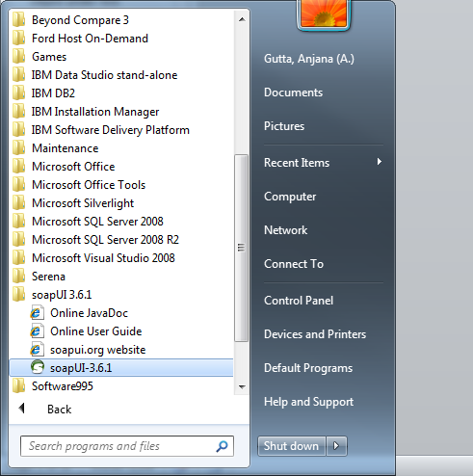

soapUI is opened
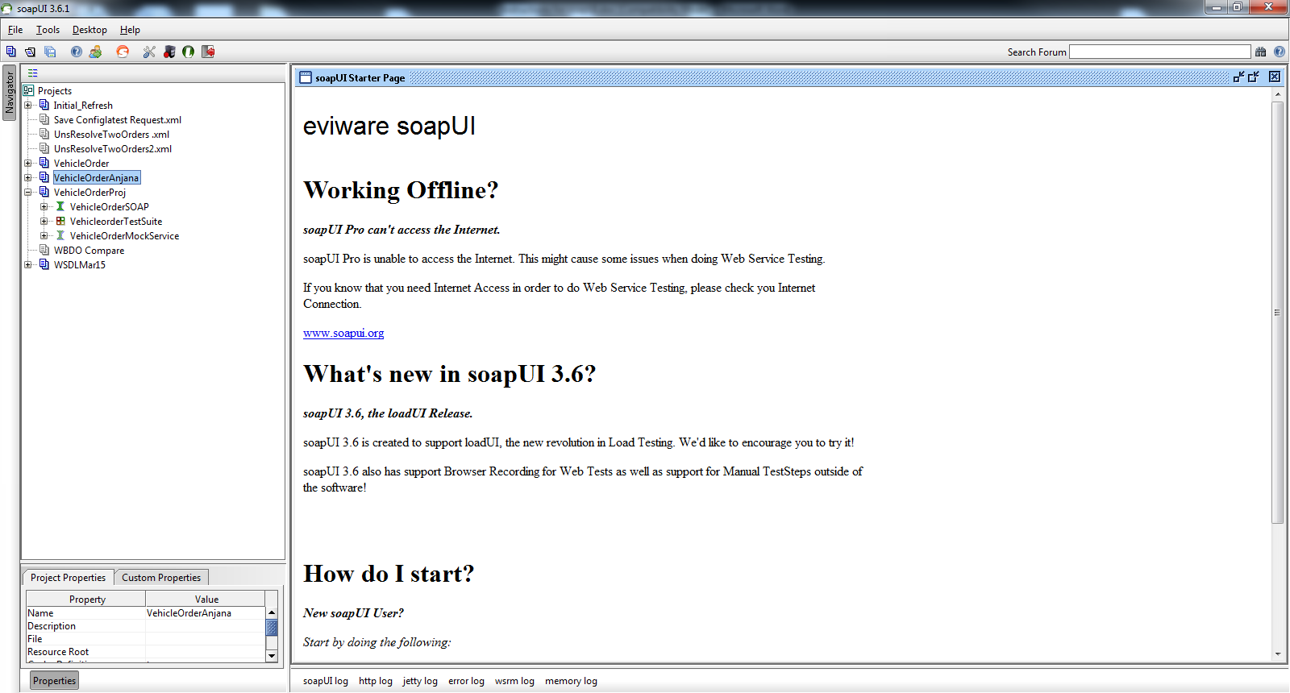

Once it opens from the “File” toolbar option
- Select New soapUI project
  - Create Project Name
- Then click on Browse button
- Select .wsdl file from C: drive

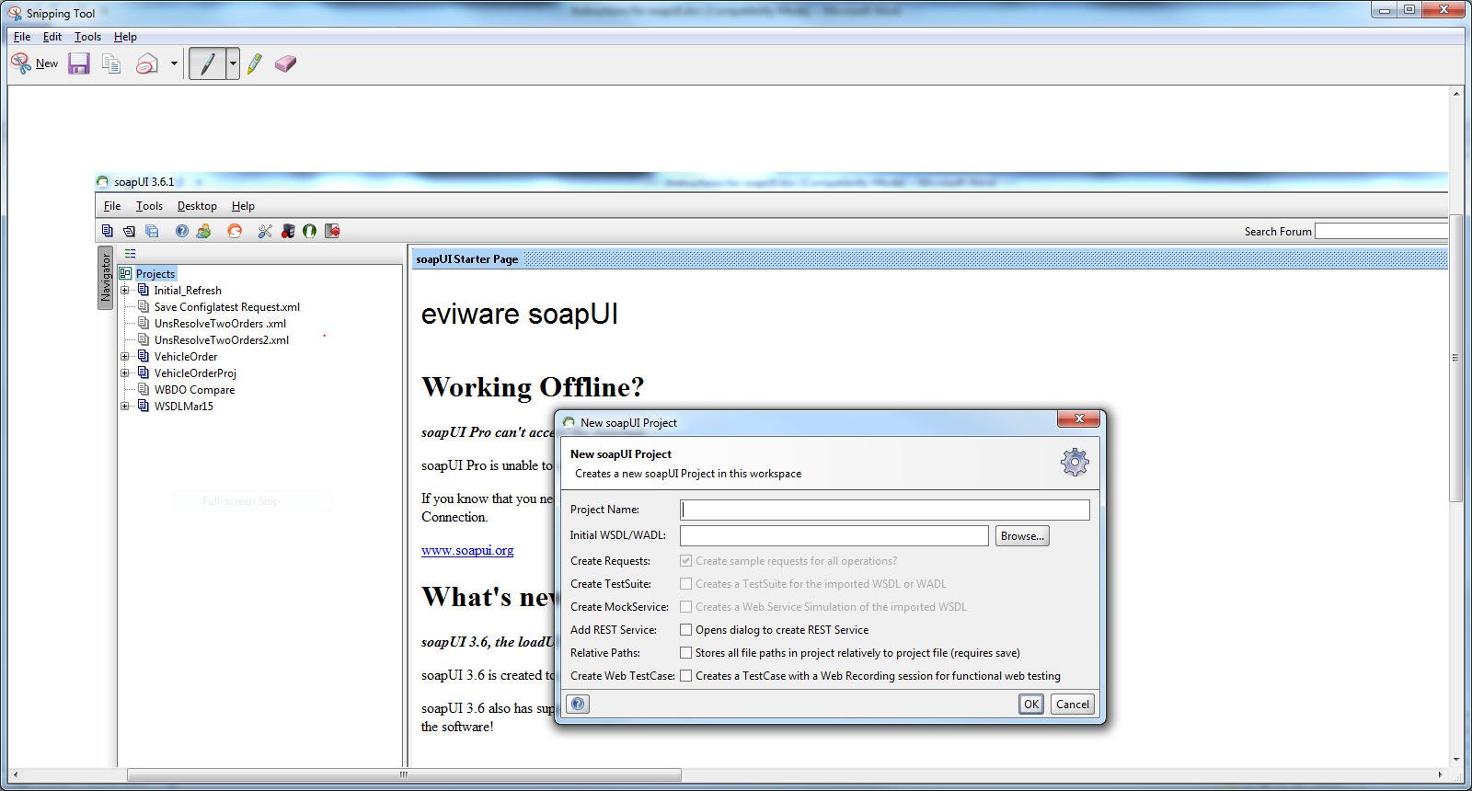

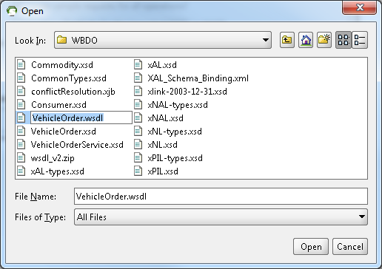

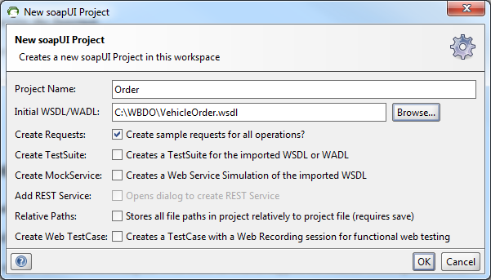

On the left side of the Navigation bar user can see all the webservice requests under the project name for corresponding operations.

Select test environment url: https://
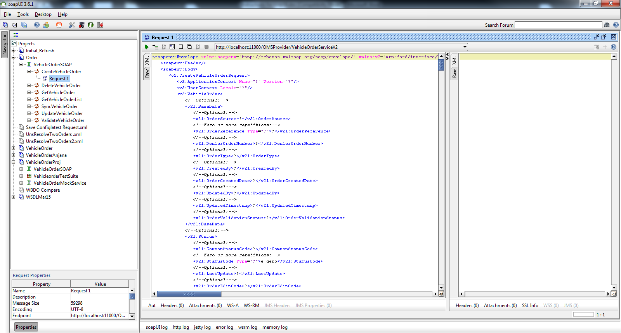

- Right click on corresponding Web service operation for a new request based on the WSDL.
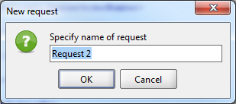

- It will automatically generate skeleton XML input request in left tab and give the test data in each corresponding tags.
- User should know the correct data as well as what are the mandatory and optional fields’ data.

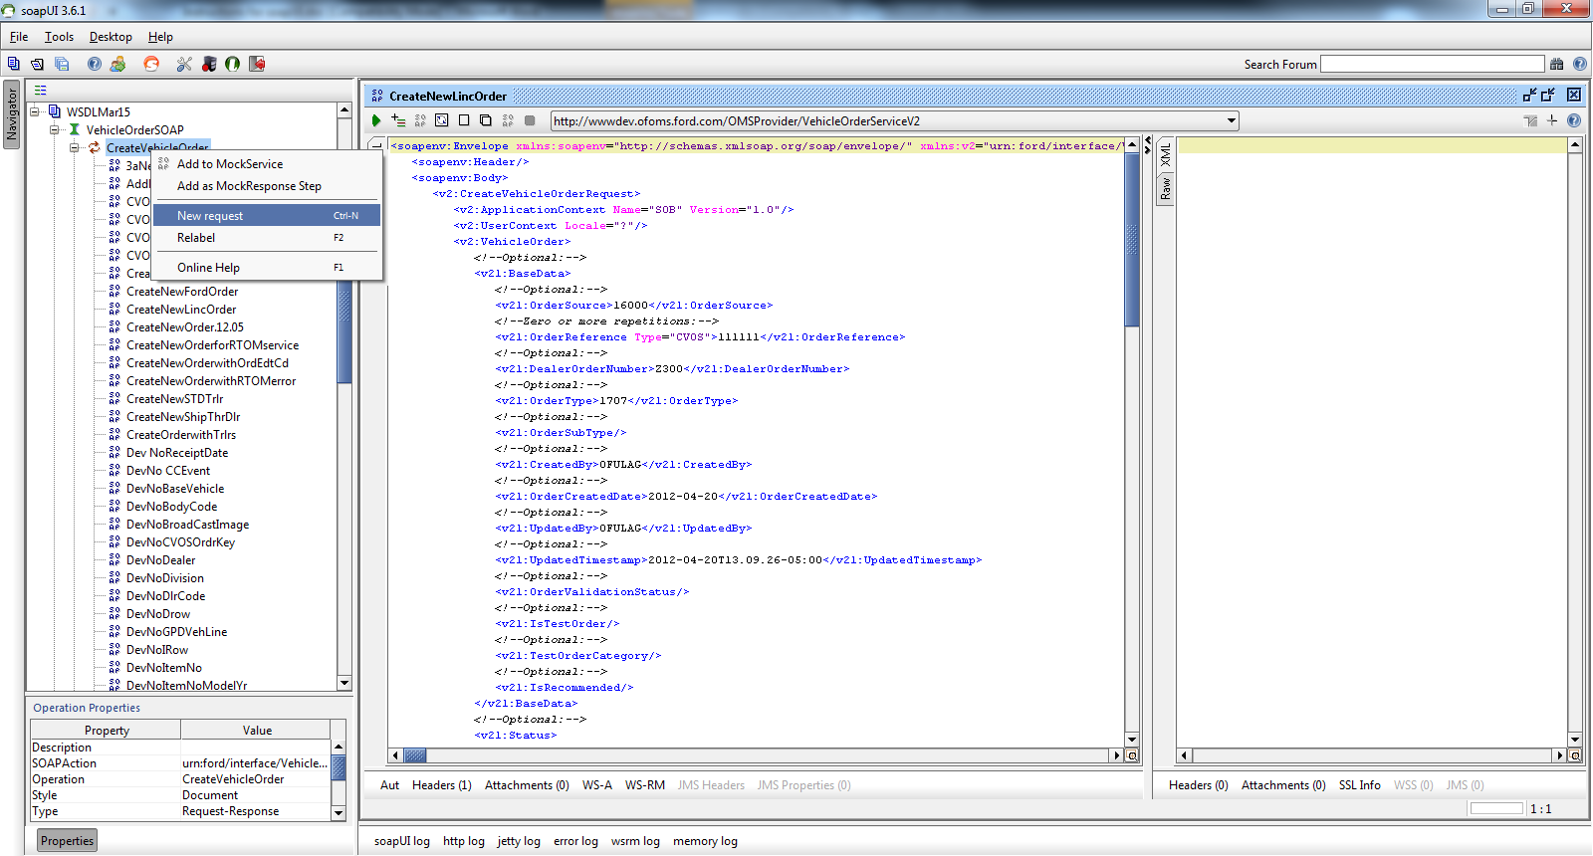

Click on Authentication and Security-related settings tab
- Enter Username
- and Password

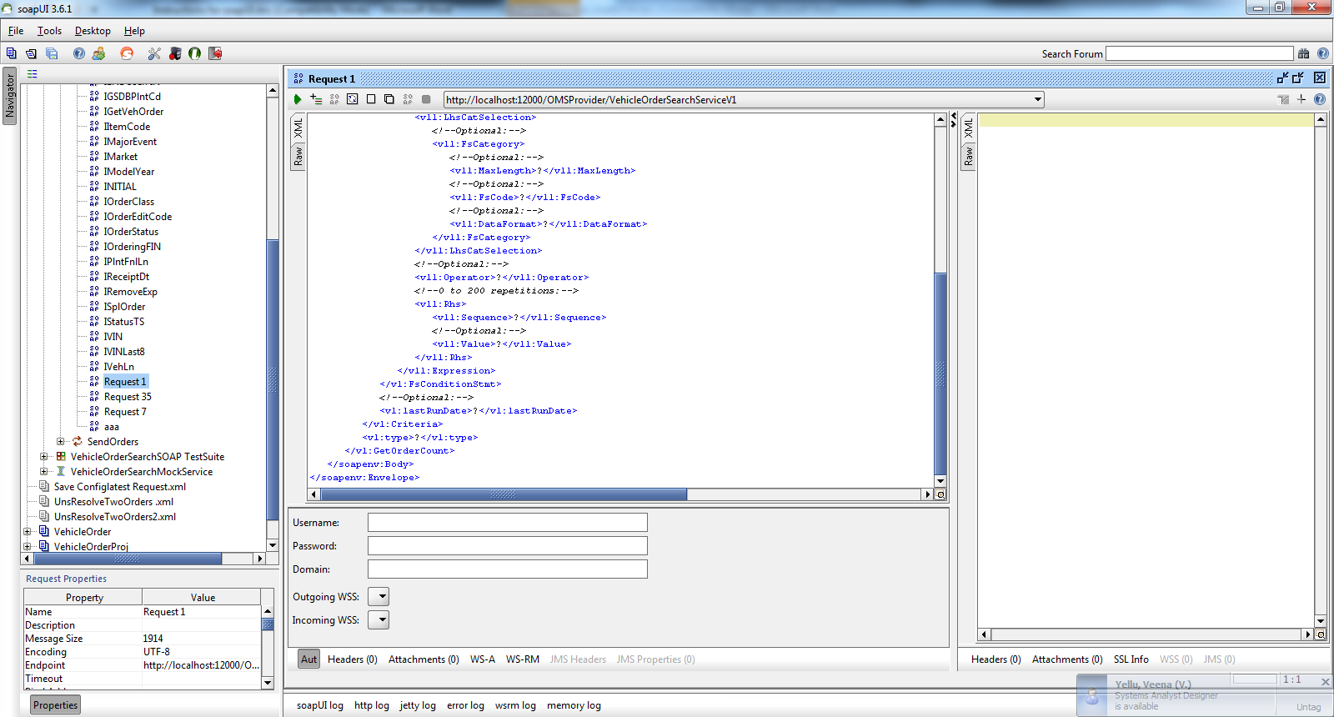

- Next Click on Headers tab
- Then click on + sign tab on top left corner above Header label.
- Then Specify name of the header to add and click OK

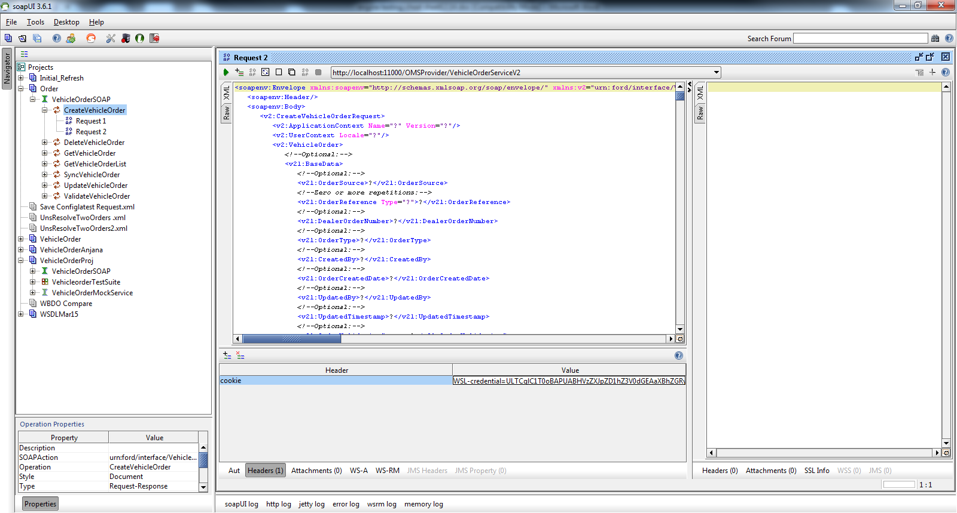

Cookie expires once in 24 hours, to get the cookie please go to the below link:
Click on the "www.cns.ford.com" link, following login screen will appear.
Then web single page displays:
- Enter CDS ID in the ‘CDS ID' field.
- Enter the network password in the 'Password' field
- Click on ‘I concur’

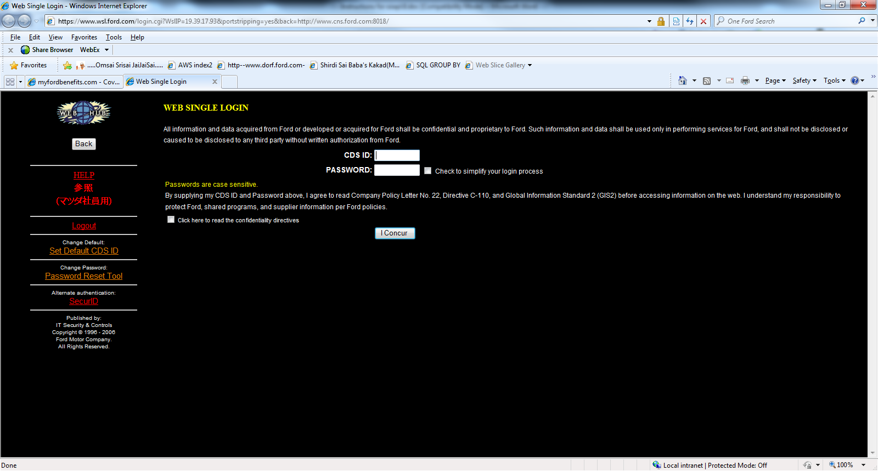

Below screen displays:
Then click on Web Single Login:
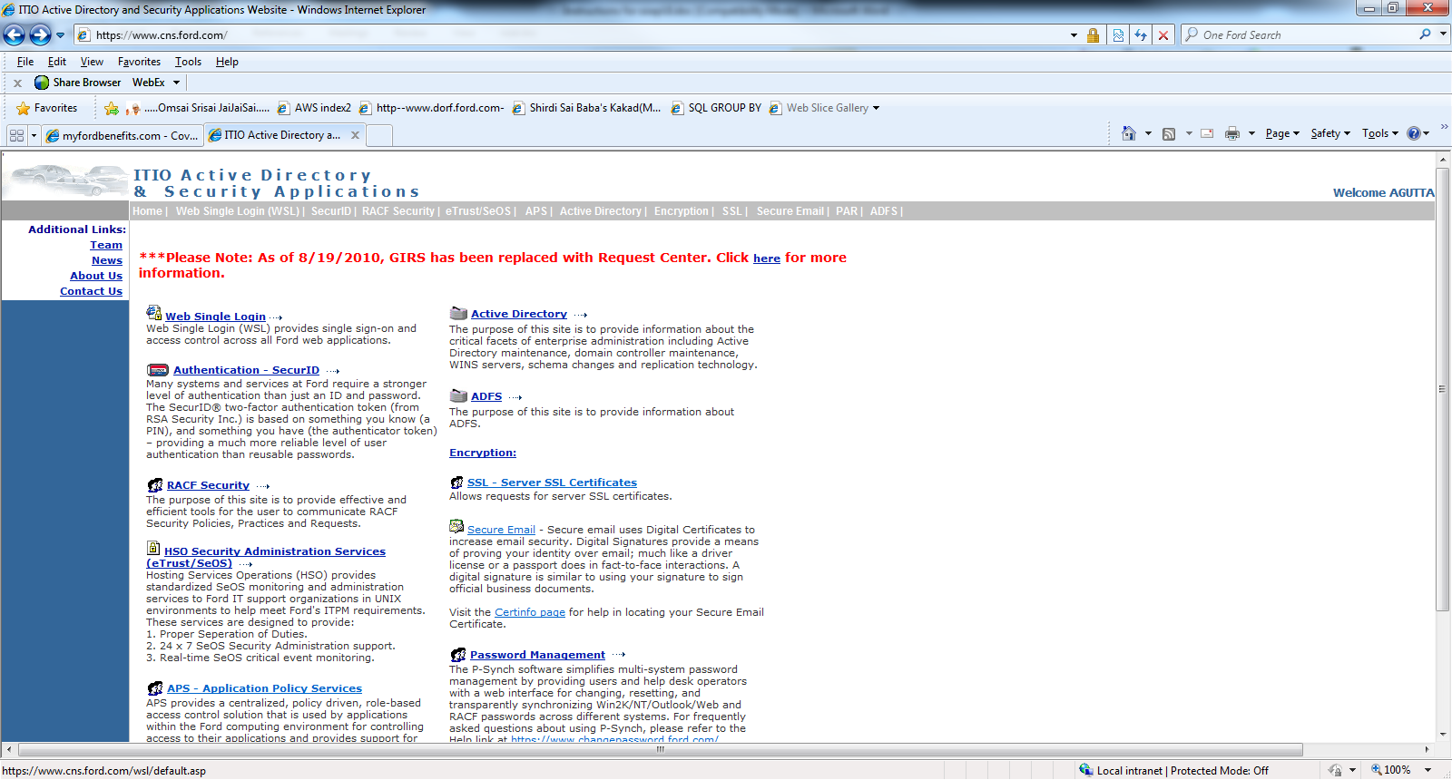
Below screen displays: Click on ‘My Cookie’

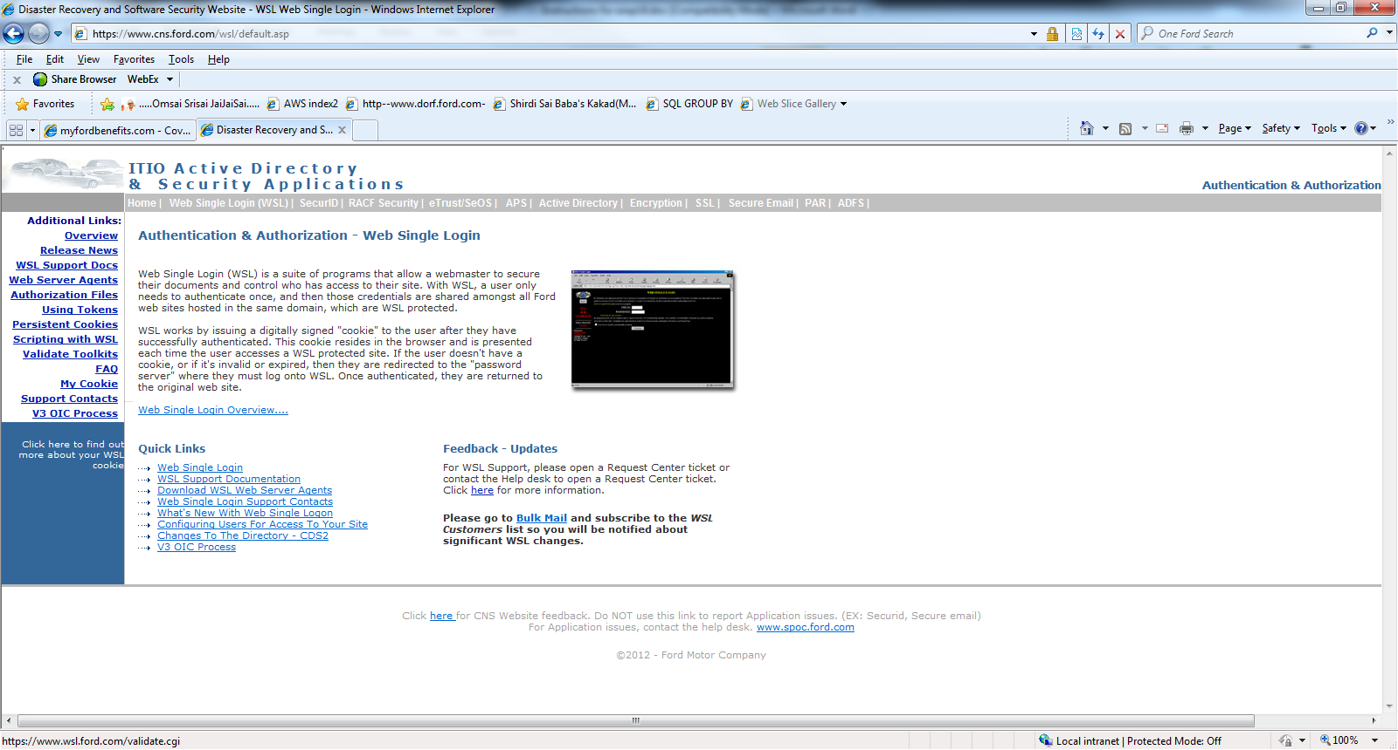

Then copy the cookie message.
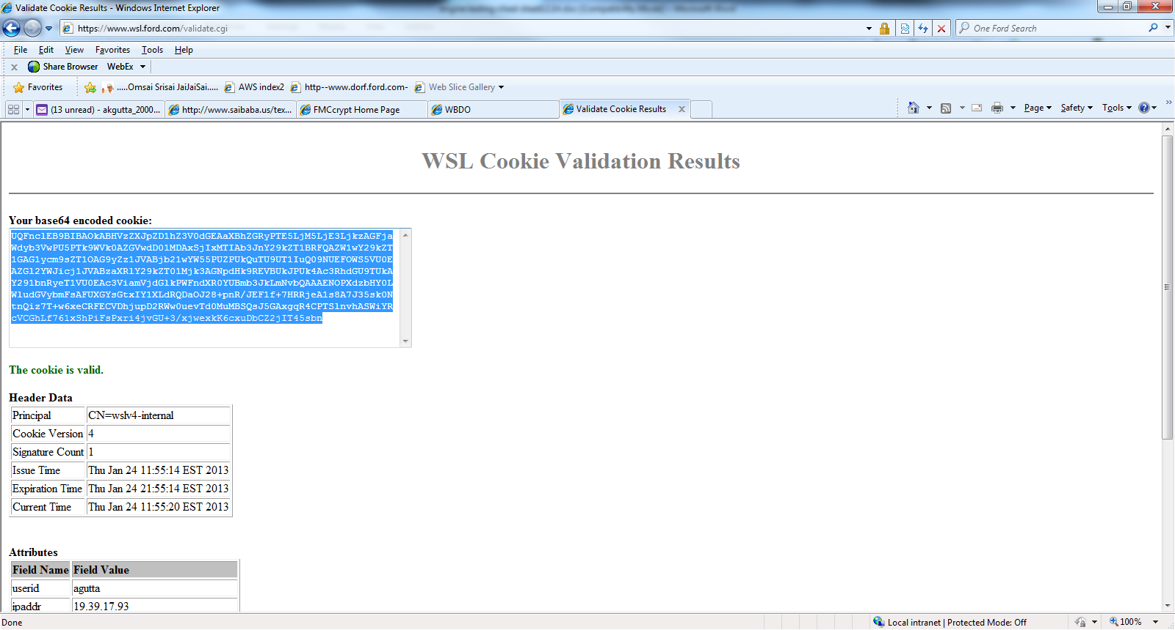

And paste in soapUI3.6.1 cookie pane after WSL -credential=
Credentials
After entering the data click on green arrow to Submit Request to specify end point url.
Then response will be displayed on right side pane.

